**IST659 – Data Admin Concepts & Db Mgmt**

**Lab1 - Ramasamy Seenivasagamani – Sanjeev**

**Data Modelling - I using Visio & Access**

1. **ERD**

To show multi-variable attribute in the ERD, select the line denoting the relationship. Under “*Set End Symbol”* choose *“One or more”*. This will change the relationship from “*one to one*” to “*one to many*”.

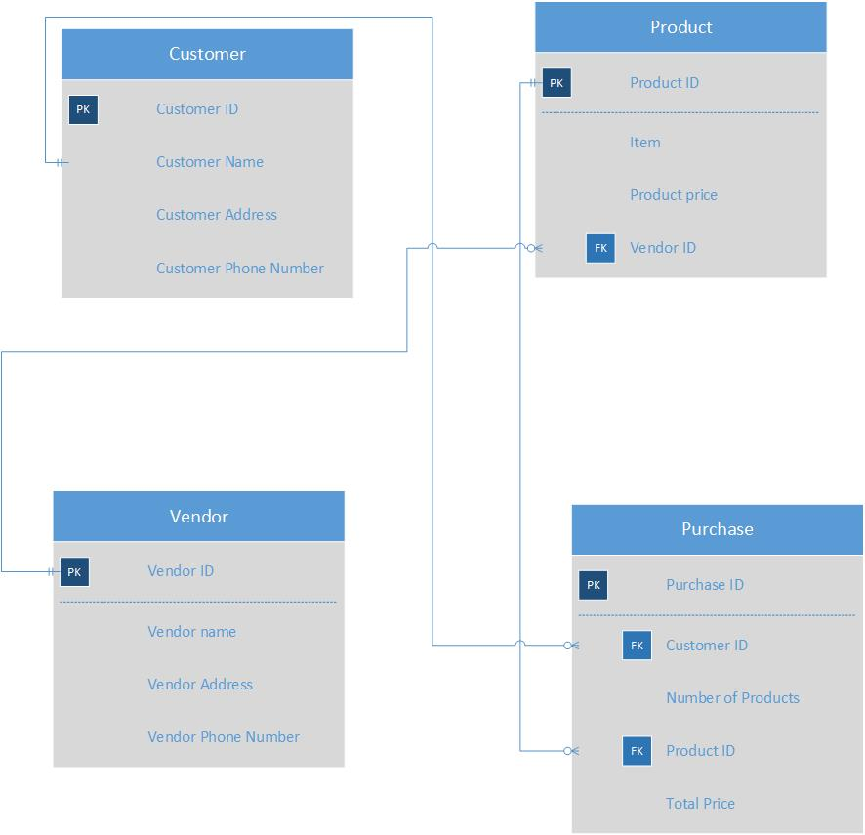

1. **Tables – Datasheet View**

* **Purchase**

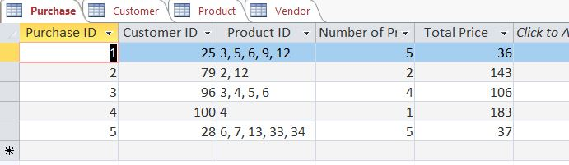

* **Product**

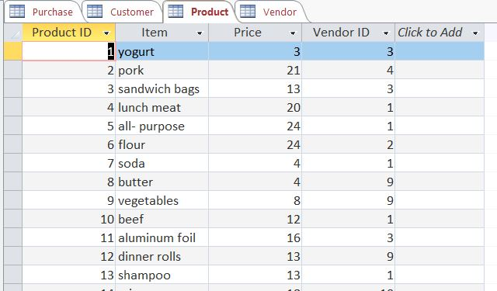

* **Customer**

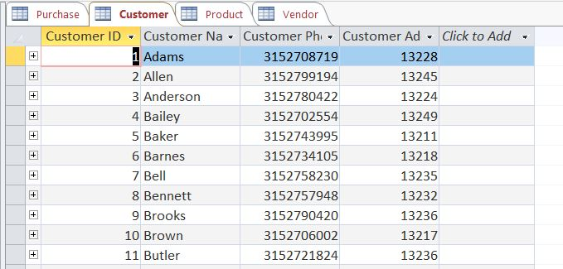

* **Vendor**

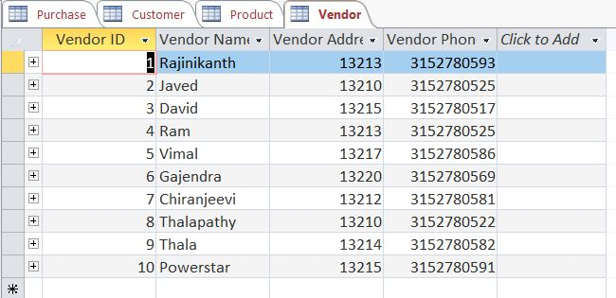

1. **Relationship Report**

